**Khana-e-Noor Database Management System**

**A PROJECT REPORT**

SUBMITTED IN PARTIAL FULFILLMENT OF THE REQUIREMENTS FOR THE AWARD OF

THE DEGREE OF

**BACHELOR OF COMPUTER SCIENCE**

**SUBMITTED TO**

**ARIA UNIVERSITY**

**SUBMITTED BY**

(Jamal Naser “Habibi”) (7/23/2022)

**SUPERVISED BY**

Dr. Yama “Ramin”



**ARIA UNIVERSITY, AMIRY RESIDENTIAL TOWN, BALKH, AFGHANISTAN**

# ACKNOWLEDGEMENT

Humans are social creatures of Allah J, from the birth to the death these creatures need each other to get their life’s objectives. Firstly, I thank from the who that paved the opportunity for me to learn and then face me with the noble personalities to do this project as my bachelor degree defense.

I would like to place on record my deep sense of gratitude to Mr. Jawid Mowahed, HOD of BCS, Aria University, Afghanistan for his generous guidance, help and useful suggestions.

I express my sincere gratitude to Dr. Yama Ramin instructor in Aria University, Afghanistan for his stimulating guidance, continuous encouragement and supervision throughout the course of present work.

I am extremely thankful to Abdul Majid Nusratyar, the leader crops of Aria University, for providing me infrastructural facilities to work in, without which this work would not have been possible.

With regard

Jamal Naser “Habibi”

# CERTIFICATE

I hereby certify that the work which is being presented in the BCS Project Report entitled **“Khana-e-Noor Management System”,** in partial fulfillment of the requirements for the award of the **Bachelor of Computer Science** and submitted to the Department of BCS, Aria University, Afghanistan is an authentic record of my own work carried out during a period from **2018 to 2021** (**8th semesters**) under the supervision of Dr. Yama “Ramin”

The matter presented in this Project Report has not been submitted by me for the award of any other degree elsewhere.

Jamal Naser “Habibi” (7/23/2022)

This is to certify that the above statement made by the student(s) is correct to the best of my knowledge.

Date: 23/7/2022 Dr. Yama “Ramin” ( the supervision teacher )

Mr. Jawid Mowahed (HoD)

BCS Department

# ABBREVIATIONS

KEN Khana-e-Noor Educational Network

DBM Database Management System

RDBM Relational Database Management System

MySQL Structured Query Language

DB Database

HTML Hyper Text markup language

CSS Cascading style sheet.

PHP Pre-hypertext processor

GUI Graphic User Interface.

IDE Integrated Development Environment

DFD Data Flow Diagram

**Content**

Contents

1 ACKNOWLEDGEMENT ii

CERTIFICATE iii

ABBREVIATIONS iv

**Chapter 1 | Introduction** 1

Khana-e-Noor Educational Network (KEN) 1

Importance of this system 1

Features of this system 2

**Chapter 2 | Used Technology** 3

DBMS 3

RDBMS 4

Web Application 8

The Web 9

Three-Tier Architectures 10

Frontend development 11

Color Palate 12

HTML 13

What's HTML? 14

What Makes Up an HTML Document? 14

HTML root element 14

CSS 15

jQuery 16

Why jQuery is required 17

Bootstrap 18

Why use Bootstrap 18

Back-end development 18

MySQL 19

MySQL is widely compatible 20

MySQL databases are relational 21

MySQL is open-source 21

MySQL is easy to use 22

PHP 22

Why use PHP? 23

What does PHP stand for? 24

What is PHP used for? 24

Server-side scripting 24

Writing desktop applications 24

How to Use PHP? 25

Advantages of PHP 25

Declining in popularity 26

Who uses PHP? 26

Javascript 26

Adding interactive behavior to web pages 27

What Would the Web Look Like Without JavaScript? 28

How JavaScript Makes Things Dynamic 28

JavaScript History 28

**Chapter 3 | Signing in and Signing out 29**

User Account 29

Creating new account 30

Login page 30

Deleting and updating user accounts 31

**Chapter 4 | The dashboard 32**

Accessing the system 33

# Chapter 1 | Introduction

# Khana-e-Noor Educational Network (KEN)

Khane Noor Private High School, which is one of the leading schools providing basic school education, was established and started operating in 2013, and as the first private school in Kabul, the Ministry of Education licensed it.

KEN is an educational brand serving to the large number of applicants and people's satisfaction with this educational institution; different agencies were established in the parts of Kabul city. Different students from different provinces started to learn modern science and knowledge in these schools.

In 2016, the educative system of KEN encouraged the students of this high school and suggested by the parents to the school to establish its representative office in north of Afghanistan so that the students can easily attend their classes.

Sixteen years before today, on the initiative of a man of courage, determination and perseverance, he stood up in this land and worked hard to create a private school, and with the greatness and strong will he had in this field, he succeeded in creating a school that will be a shining crown on the education of the country. Yes, Nurullah Davoudzi is a man of knowledge and a lover of knowledge, who considers the education, education and training of the children of this land as his special love and interest in life. In addition, this will of his, despite the many challenges and problems that came his way could never shake his motivation and decision in the direction of education and serving. In a short period, he was able to build Khane-e-Noor into a large educational network, which today has Five schools and two higher education universities, which is the home of light and elites. On the beginning of Khane Noor School, which had 220 students in the first days of its establishment in Mazar-e-Sharif, was able to graduate hundreds of male and female students from this center and present it to the educational community inside and outside the country. The employees and students of this school have many memories of this center over the years.

# Importance of this system

Every organization needs management when there is a massive number of people. One of the main base of an organization that we informational resources that gather all data about every single item of a system. Such a system seemed to be installed to be responsible against all the existing problems, after initiating the requirement this system build and respond all the needs of the school management system.

# Features of this system

* Registering all the students to the system.
* Enrolling the students to the any created grade.
* Managing financial affairs.
* Printing payment bale.
* Managing all the bookshop transactions.
* Managing scoring and resulting of students.
* Messaging channel.
* Printing Payment bale with auto calculation.
* Printing detailed mark chart (DMC).
* Multiuser with specified accessibility.
* Tracking user’s activity.
* Profile form for new hiring teachers.
* Profile for all enrolled students.
* Fast, secured, branding design and easy.

# Chapter 2 | Used Technology

# DBMS

Database Management Systems (DBMS) are software systems used to store, retrieve, and run queries on data. A DBMS serves as an interface between an end-user and a database, allowing users to create, read, update, and delete data in the database.

DBMS manage the data, the database engine, and the database schema, allowing for data to be manipulated or extracted by users and other programs. This helps provide data security, data integrity, concurrency, and uniform data administration procedures.

DBMS optimizes the organization of data by following a database schema design technique called normalization, which splits a large table into smaller tables when any of its attributes have redundancy in values. DBMS offer many benefits over traditional file systems, including flexibility and a more complex backup system.

Database management systems can be classified based on a variety of criteria such as the data model, the database distribution, or user numbers. The most widely used types of DBMS software are relational, distributed, hierarchical, object-oriented, and network.

DBMS manage the data, the database engine, and the database schema, allowing data to be manipulated or extracted by users and other programs. This helps provide data security, data integrity, concurrency, and uniform data administration procedures.

DBMS optimizes the organization of data by following a database schema design technique called normalization, which splits a large table into smaller tables when any of its attributes have redundancy in values. DBMS offer many benefits over traditional file systems, including flexibility and a more complex backup system.

Database management systems can be classified based on a variety of criteria such as the data model, the database distribution, or user numbers. The most widely used types of DBMS software are relational, distributed, hierarchical, object-oriented, and network.

*The database diagram of the system*

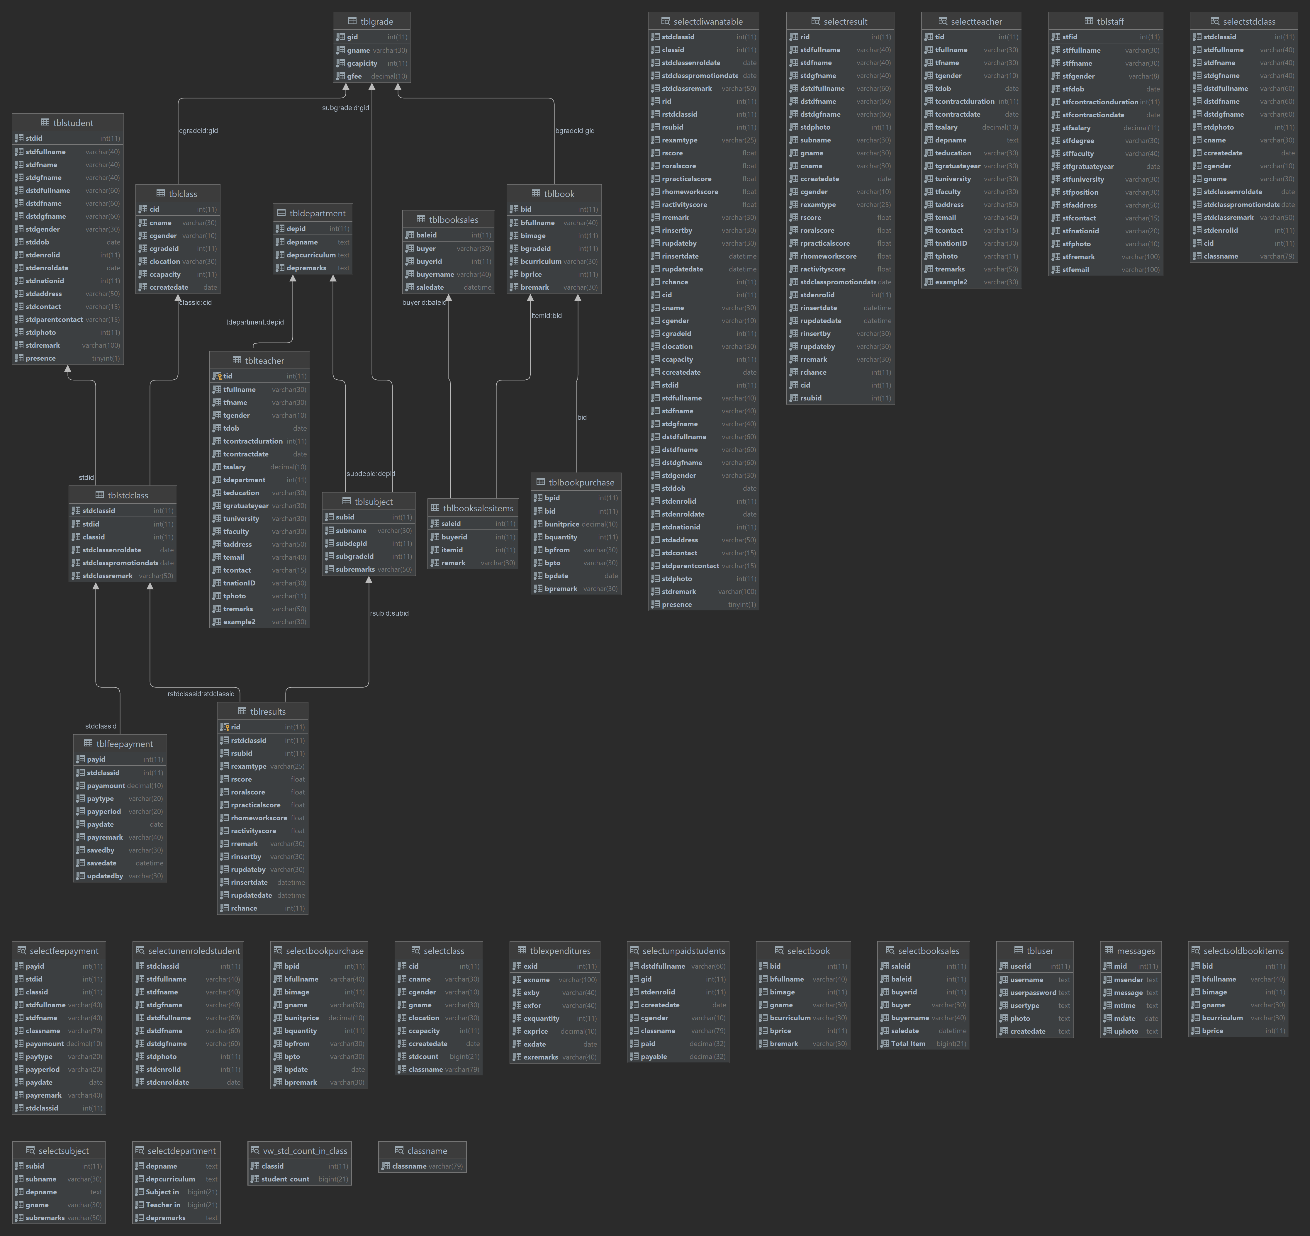

# RDBMS

To the addition of above information about DBMS a RDBMS stands for Relational Database Management System. RDBMS is the basis for SQL, and for all modern database systems like MS SQL Server, IBM DB2, Oracle, MySQL, and Microsoft Access.

All modern database management systems like SQL, MS SQL Server, IBM DB2, ORACLE, My-SQL, and Microsoft Access are based on RDBMS.

A Relational database management system (RDBMS) is a database management system (DBMS) that is based on the relational model as introduced by E. F. Codd.

**Entity Integrity:** No two records of the database table can be completely duplicate.

**Referential Integrity:** Only the rows of those tables can be deleted which are not used by other tables. Otherwise, it may lead to data inconsistency.

**User-defined Integrity:** Rules defined by the users based on confidentiality and access.

**Domain integrity:** The columns of the database tables are enclosed within some structured limits, based on default values, type of data or ranges.

**Characteristics**

Data must be stored in tabular form in DB file, that is, it should be organized in the form of rows and columns.

Each row of table is called record/tuple. Collection of such records is known as the cardinality of the table

Each column of the table is called an attribute/field. Collection of such columns is called the arity of the table.

No two records of the DB table can be same. Data duplicity is therefore avoided by using a candidate key. Candidate Key is a minimum set of attributes required to identify each record uniquely.

Tables are related to each other with the help for foreign keys.

Database tables also allow NULL values that is if the values of any of the element of the table are not filled or are missing, it becomes a NULL value, which is not equivalent to zero. (NOTE: Primary key cannot have a NULL value).

**Example:**

The following table STUDENT consists of three columns Roll Number, Name, Section and four records of students 1, 2, 3 and 4 respectively. The records can’t be completely same, the Roll Number acts as a candidate key which separates records.

|  |  |  |
| --- | --- | --- |
| Roll number | Name | Class |
| 1 | Abdullah | 9th A |
| 2 | Ahmad Royan | 10th B |
| 3 | Shahnam | 5th C |
| 4 | Abdul Rahman | 8th A |

**Advantages**

Easy to manage: Each table can be independently manipulated without affecting others.

Security: It is more secure consisting of multiple levels of security. Access of data shared can be limited.

Flexible: Updating of data can be done at a single point without making amendments at multiple files. Databases can easily be extended to incorporate more records, thus providing greater scalability. Also, facilitates easy application of SQL queries.

Users: RDBMS supports client-side architecture storing multiple users together.

Facilitates storage and retrieval of large amount of data.

**Easy Data Handling:**

Data fetching is faster because of relational architecture.

Data redundancy or duplicity is avoided due to keys, indexes, and normalization principles.

Data consistency is ensured because RDBMS is based on ACID properties for data transactions (Atomicity Consistency Isolation Durability).

Fault Tolerance: Replication of databases provides simultaneous access and helps the system recover in case of disasters, such as power failures or sudden shutdowns

**Disadvantages**

High Cost and Extensive Hardware and Software Support: Huge costs and setups are required to make these systems functional.

**Scalability:** In case of addition of more data, servers along with additional power, and memory are required.

**Complexity:** Voluminous data creates complexity in understanding of relations and may lower down the performance.

**Structured Limits:** The fields or columns of a relational database system is enclosed within various limits, which may lead to loss of data.

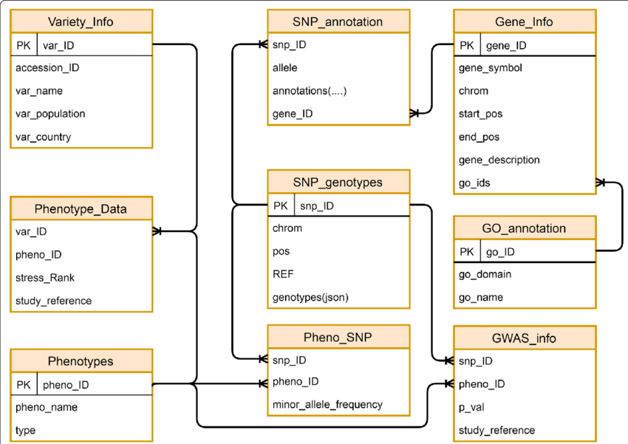

# Web Application

Most of the services we enjoy on the Web are provided by web database applications. Web-based email, online shopping, forums and bulletin boards, corporate web sites, and sports and news portals are all database-driven. To build a modern web site, you need to develop a database application.

This book presents a highly popular, easy, low-cost way to bring together the Web and databases to build applications. The most popular database management system used in these solutions is MySQL, a very fast and easy-to-use system distributed under an Open-Source license by its manufacturer, MySQL AB. We discuss MySQL in detail in this book.

With a web server such as Apache (we assume Apache in this book, although the software discussed here works with other web servers as well) and MySQL, you have most of what you need to develop a web database application. The key glue you need is a way for the web server to talk to the database; in other words, a way to incorporate database operations into web pages. The most popular glue that accomplishes this task is PHP.

PHP is an open-source project of the Apache Software Foundation and it’s the most popular Apache web server add-on module, with around 53% of the Apache HTTP servers having PHP capabilities. PHP is particularly suited to web database applications because of its integration tools for the Web and database environments. In particular, the flexibility of embedding scripts in HTML pages permits easy integration of HTML presentation and code. The database tier integration support is also excellent, with more than 15 libraries available to interact with almost all popular database servers. In this book, we present a comprehensive view of PHP along with a number of powerful extensions provided by a repository known as PEAR.

Apache, MySQL, and PHP can run on a wide variety of operating systems. In this book, we show you how to use them on Linux, Mac OS X, and Microsoft Windows.

This is an introductory book, but it gives you the sophisticated knowledge you need to build applications properly. This includes critical tasks such as checking user input, handling errors robustly, and locking your database operations to avoid data corruption. Most importantly, we explain the principles behind good web database applications. You’ll finish the book with not only the technical skills to create an application, but also an appreciation for the strategies that make an application secure, reliable, maintainable, and expandable.

# The Web

When you browse the Web, you use your web browser to request resources from a web server and the web server responds with the resources. You make these requests by filling in and submitting forms, clicking on links, or typing URLs into your browser. Often, resources are static HTML pages that are displayed in the browser. Figure 1-1 shows how a web browser communicates with a web server to retrieve this book’s home page. This is the classic two-tier or client-server architecture used on the Web.

A two-tier architecture where a web browser makes a request and the web server responds

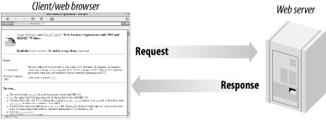

Figure 1-1. A two-tier architecture where a web browser makes a request and the web server responds

A web server is not sophisticated storage software. Complicated operations on data, done by commercial sites and anyone else presenting lots of dynamic data, should be handled by a separate database. This leads to a more complex architecture with three-tiers: the browser is still the client tier, the web server becomes the middle tier, and the database is the third or database tier. Figure 1-2 shows how a web browser requests a resource that’s generated from a database, and how the database and web server respond to the request.

A three-tier architecture where a web browser requests a resource, and a response is generated from a database

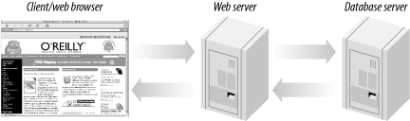

Figure 1-2. A three-tier architecture where a web browser requests a resource, and a response is generated from a database

# Three-Tier Architectures

Figure 1-3. At the base of an application is the database tier, consisting of the database management system that manages the data users create, delete, modify, and query. Built on top of the database tier is the middle tier, which contains most of the application logic that you develop. It also communicates data between the other tiers. On top is the client tier, usually web browser software that interacts with the application.

The three-tier architecture model of a web database application

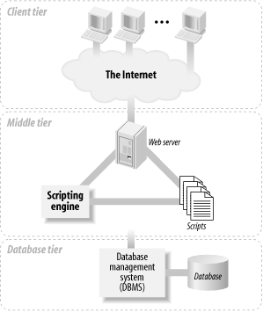

The three-tier architecture model of a web database application

The three-tier architecture is conceptual. In practice, there are different implementations of web database applications that fit this architecture. The most common implementation has the web server (which includes the scripting engine that processes the scripts and carries out the actions they specify) and the database management system installed on one machine: it’s the simplest to manage and secure, and it’s our focus in this book. With this implementation on modern hardware, your applications can probably handle tens of thousands of requests every hour.

For popular web sites, a common implementation is to install the web server and the database server on different machines, so that resources are dedicated to permit a more scalable and faster application. For very high-end applications, a cluster of computers can be used, where the database and web servers are replicated and the load distributed across many machines. Our focus is on simple implementations; replication and load distribution are beyond the scope of this book.

Describing web database applications as three-tier architectures makes them sound formally structured and organized. However, it hides the reality that the applications must bring together different protocols and software, and that the software needs to be installed, configured, and secured.

# Frontend development

Front end developers build with the user in mind. Front end development is a style of computer programming that focuses on the coding and creation of elements and features of a website that will then be seen by the user. It’s about making sure the visual aspects of a website are functional. You can also think of front end as the “client side” of an application. So, let’s say you’re a front-end developer. This means your job is to code and bring to life the visual elements of a website. You’d be more focused on what the user sees when they visit a website or app. And, you’d want to make sure the site is easy to interact with while also running smoothly.

These developers take the visual designs from UX and UI designers and bring the website to life, making sure it functions well for the user. One of the many ways you could use front end skills is in creating a static website, which is a website with fixed content that’s delivered to a user’s browser exactly as it’s stored. You might run into a static website if you happen upon a simple landing page or a small business website that doesn’t allow users to perform any interactive tasks.

Front end developers build elements like:

* Buttons
* Layouts
* Navigation
* Images
* Graphics
* Animations
* Content organization

On the front-end of this project, I use the following technologies

1. HTML – for structuring the webpage
2. CSS – for styling the html tags
3. jQuery – to add some extra user interface interactive view
4. Bootstrap – to use advance CSS easily.

# Color Palate

A color palette, in the digital world, refers to the full range of colors that can be displayed on a device screen or other interface, or in some cases, a collection of colors and tools for use in paint and illustration programs. The color palette reveals a lot about the electronic design of the device or technology, and its visual capabilities for human users.

A color palette is also known simply as a palette.

The digital color palette emerged from the earliest computers, which only had monochrome displays. Early examples include the Teletext format with a three-bit RGB eight-color palette and the Apple II personal computer with a 16-color palette. Devices like early Atari, Commodore and Apple computers and consoles used their own evolving color palettes built on new color technology.

Eventually, advances in display technology introduced a 256-color VGA display that remained a standard until the creation of modern flat-screen plasma screen monitors.

Early color palettes used hexadecimal values to represent and select the array of colors possible in the display systems. Modern color palettes are more likely to show users a color wheel or sophisticated color selection tool to choose from a wide variety of hues and shades of color. It is worth noting that the advancement in digital color palettes and video display color choices coincided with and allowed for the rapid evolution of the modern digital camera, which has now been embedded into smartphones and mobile devices.

***The color palate used for this project***

# HTML

HTML stands for hypertext markup language. It's made of keywords and commands that web designers use for creating websites.

The Hypertext Markup Language or HTML is the standard markup language for documents designed to be displayed in a web browser. It can be assisted by technologies such as Cascading Style Sheets (CSS) and scripting languages such as JavaScript.

Web browsers receive HTML documents from a web server or from local storage and render the documents into multimedia web pages. HTML describes the structure of a web page semantically and originally included cues for the appearance of the document.

HTML elements are the building blocks of HTML pages. With HTML constructs, images and other objects such as interactive forms may be embedded into the rendered page. HTML provides a means to create structured documents by denoting structural semantics for text such as headings, paragraphs, lists, links, quotes and other items. HTML elements are delineated by tags, written using angle brackets. Tags such as <img /> and <input /> directly introduce content into the page. Other tags such as <p> surround and provide information about document text and may include other tags as sub-elements. Browsers do not display the HTML tags but use them to interpret the content of the page.

HTML can embed programs written in a scripting language such as JavaScript, which affects the behavior and content of web pages. Inclusion of CSS defines the look and layout of content. The World Wide Web Consortium (W3C), former maintainer of the HTML and current maintainer of the CSS standards, has encouraged the use of CSS over explicit presentational HTML since 1997. A form of HTML, known as HTML5, is used to display video and audio, primarily using the <canvas> element, in collaboration with JavaScript.

Hypertext is text with links that readers can simply click on to go to another page or another part of the page. Meanwhile, markup language uses tags or plain text with special markings to define the sections of a page, such as headers and footers, and other elements, including tables and images.

HTML is considered one of the three essential tools in webpage creation: HTML provides the structure or the way text, pictures, and so on will appear on the website. CSS (cascading style sheets) sets the visual properties of these elements, such as colors, format, and layout. Meanwhile, JavaScript makes these elements behave in certain ways depending on a user's action. For example, the font size of text can increase when users hover their mouse or click a button on a page.

To write HTML, you'll need a text editor, like Notepad, Brackets, or Atom. HTML editors make sure your coding is clean and functional. They help reduce errors by automatically inserting tags (auto-completion) and other common elements or through debugging.

# What's HTML?

HTML is the default language of websites and web-based documents. It helps a browser understand the structure and style of a document or files for viewing over the internet. It allows your web pages to host audio, videos, spreadsheets, and other applications. It also facilitates navigation within web pages or between websites through hypertext.

Moreover, website makers can use HTML to design forms for ordering products, making reservations, or searching for information. HTML is, therefore, the basic building block for building your brand and running an e-commerce site or an online subscription-based business.

# What Makes Up an HTML Document?

The primary components of an HTML document are tags and elements. They tell your browser how to display your content. Tags start and end with angled brackets or the "less than" and "greater than" signs. Letters between them are called element contents.

The following make up the basic structure of an HTML page (in their order of appearance):

**Document type declaration (DTD)**

The <!DOCTYPE html> appears at the start or very top of an HTML document. It tells the browser what HTML version was used to produce the page.

# HTML root element

The <html>, which is written below the DTD, acts like the "main container" that holds all the other elements. It can specify the language of the HTML document. For instance <html lang="en-US"> means the page is written in American English.

**Head**

The <head>, which you'll find between <html> and <body>, contains metadata describing information about the page. They include:

The <title> or the overall subject of the webpage. It's separate from but should match the headline tag that appears in the body.

The <style> defines how elements should show up in the browser. This includes the color of the headline, text alignment, background color of the body, and so on.

The <link> indicates the resources (i.e. another webpage or external style sheet) linked to the HTML page.

The <meta> contains keywords, author, and page description.

The <base> refers to the default URL.

**Body**

The <body> is the main portion of the document that contains the information, which the browser displays on the screen. It can include the following:

The header features the site title, logo, main navigation, and search bar.

The main content covers the article title or heading, article content, date posted, author, and so on.

The sidebars display widgets and secondary navigation, such as archives by category or date.

The footer offers contact info, social links, copyright, and tertiary navigation.

How Does HTML Work?

The website author types an HTML document that's saved with an extension .html or .htm (filename.html or filename.htm). This file is then uploaded to the Worldwide Web, which would show how it looks online.

To open the HTML file from your PC, go to File Explorer, right-click the file (or double-click it if you're using Mac) and select "Open with" from the menu to launch in your preferred browser. Google Chrome, Mozilla Firefox, Safari, and other browsers can recognize and read this format. You can also launch your browser, press Ctrl+O to pull up the "open" menu, and double-click your html file.

The browsers use the HTML elements to interpret the content of the page and render them correctly on the screen in a neat and formatted way.

# CSS

Cascading Style Sheets (CSS) is a style sheet language used for describing the presentation of a document written in a markup language such as HTML or XML (including XML dialects such as SVG, MathML or XHTML). CSS is a cornerstone technology of the World Wide Web, alongside HTML and JavaScript.

CSS is designed to enable the separation of presentation and content, including layout, colors, and fonts. This separation can improve content accessibility; provide more flexibility and control in the specification of presentation characteristics; enable multiple web pages to share formatting by specifying the relevant CSS in a separate .css file, which reduces complexity and repetition in the structural content; and enable the .css file to be cached to improve the page load speed between the pages that share the file and its formatting.

Separation of formatting and content also makes it feasible to present the same markup page in different styles for different rendering methods, such as on-screen, in print, by voice (via speech-based browser or screen reader), and on Braille-based tactile devices. CSS also has rules for alternate formatting if the content is accessed on a mobile device.

The name cascading comes from the specified priority scheme to determine which style rule applies if more than one rule matches a particular element. This cascading priority scheme is predictable.

The CSS specifications are maintained by the World Wide Web Consortium (W3C). Internet media type (MIME type) text/css is registered for use with CSS by RFC 2318 (March 1998). The W3C operates a free CSS validation service for CSS documents.

# jQuery

jQuery is a fast, small, and feature-rich JavaScript library. It makes things like HTML document traversal and manipulation, event handling, animation, and Ajax much simpler with an easy-to-use API that works across a multitude of browsers. With a combination of versatility and extensibility, jQuery has changed the way that millions of people write JavaScript.

jQuery is a small, light-weight and fast JavaScript library. It is cross-platform and supports different types of browsers. It is also referred as write less do more? because it takes a lot of common tasks that requires many lines of JavaScript code to accomplish, and binds them into methods that can be called with a single line of code whenever needed. It is also very useful to simplify a lot of the complicated things from JavaScript, like AJAX calls and DOM manipulation.

* jQuery is a small, fast and lightweight JavaScript library.
* jQuery is platform-independent.
* jQuery means "write less do more".
* jQuery simplifies AJAX call and DOM manipulation.
* jQuery Features
* Following are the important features of jQuery.
* HTML manipulation
* DOM manipulation
* DOM element selection
* CSS manipulation
* Effects and Animations
* Utilities
* AJAX
* HTML event methods
* JSON Parsing
* Extensibility through plug-ins

# Why jQuery is required

Sometimes, a question can arise that what is the need of jQuery or what difference it makes on bringing jQuery instead of AJAX/ JavaScript? If jQuery is the replacement of AJAX and JavaScript? For all these questions, you can state the following answers.

* It is very fast and extensible.
* It facilitates the users to write UI related function codes in minimum possible lines.
* It improves the performance of an application.
* Browser's compatible web applications can be developed.
* It uses mostly new features of new browsers.
* So, you can say that out of the lot of JavaScript frameworks, jQuery is the most popular and the most extendable. Many of the biggest companies on the web use jQuery.

Some of these companies are:

1. Microsoft
2. Google
3. IBM
4. Netflix

# Bootstrap

Bootstrap is a free and open-source tool collection for creating responsive websites and web applications. It is the most popular HTML, CSS, and JavaScript framework for developing responsive, mobile-first websites. Nowadays, the websites are perfect for all the browsers (IE, Firefox, and Chrome) and for all sizes of screens (Desktop, Tablets, Phablets, and Phones). All thanks to Bootstrap developers – Mark Otto and Jacob Thornton of Twitter, though it was later declared to be an open-source project.

Bootstrap is the most popular HTML, CSS and JavaScript framework for developing a responsive and mobile friendly website. It is absolutely free to download and use. It is a front-end framework used for easier and faster web development. It includes HTML and CSS based design templates for typography, forms, buttons, tables, navigation, modals, image carousels and many others. It can also use JavaScript plug-ins. It facilitates you to create responsive designs.

# Why use Bootstrap

1. It is very easy to use. Anybody having basic knowledge of HTML and CSS can use Bootstrap.
2. It facilitates users to develop a responsive website.
3. It is compatible on most of browsers like Chrome, Firefox, Internet Explorer, Safari and Opera etc.

# Back-end development

Back-end development focuses on the side of the website users can’t see. It’s what makes a site interactive. You can also refer to the back end as the “server side” of a website. For instance, let’s say you’re running a social media website. You need an accessible place to store all of your users’ information. This storage center is called a database and a few widely used examples include Oracle, SQL Server, and MySQL. Databases are run from a server, which is essentially a remote computer. A back-end developer will help manage this database, as well as the site contents stored on it. This ensures that front end elements on your social media website can continue to function properly as users browse uploaded content and other user profiles.

While users do not directly interact with the back end of a website, they’ll indirectly interact with elements these developers work on through a front-end application. Back-end development deals with storing and arranging data while also ensuring the front end is functioning well.

Back-end web developers work on tasks like:

* Building code
* Troubleshooting and debugging web applications
* Database management
* Framework utilization

On the back-end of this project, I use the following technologies

1. MySQL – as a database management system
2. PHP – to handle transferring data to the web
3. JavaScript

# MySQL

MySQL is one of the most recognizable technologies in the modern big data ecosystem. Often called the most popular database and currently enjoying widespread, effective use regardless of industry, it’s clear that anyone involved with enterprise data or general IT should at least aim for a basic familiarity of MySQL.

With MySQL, even those new to relational systems can immediately build fast, powerful, and secure data storage systems. MySQL’s programmatic syntax and interfaces are also perfect gateways into the wide world of other popular query languages and structured data stores.

MySQL is a relational database management system (RDBMS) developed by Oracle that is based on structured query language (SQL).

Its name is a combination of "My", the name of co-founder Michael Widenius's daughter and "SQL", the abbreviation for Structured Query Language. A relational database organizes data into one or more data tables in which data may be related to each other; these relations help structure the data. SQL is a language programmer use to create, modify and extract data from the relational database, as well as control user access to the database. In addition to relational databases and SQL, an RDBMS like MySQL works with an operating system to implement a relational database in a computer's storage system, manages users, allows for network access and facilitates testing database integrity and creation of backups.

MySQL is free and open-source software under the terms of the GNU General Public License, and is also available under a variety of proprietary licenses. MySQL was owned and sponsored by the Swedish company MySQL AB, which was bought by Sun Microsystems (now Oracle Corporation).In 2010, when Oracle acquired Sun, Widenius forked the open-source MySQL project to create MariaDB.

MySQL has stand-alone clients that allow users to interact directly with a MySQL database using SQL, but more often, MySQL is used with other programs to implement applications that need relational database capability. MySQL is a component of the LAMP web application software stack (and others), which is an acronym for Linux, Apache, MySQL, Perl/PHP/Python. MySQL is used by many database-driven web applications, including Drupal, Joomla, phpBB, and WordPress. MySQL is also used by many popular websites, including Facebook,

A database is a structured collection of data. It may be anything from a simple shopping list to a picture gallery or a place to hold the vast amounts of information in a corporate network. In particular, a relational database is a digital store collecting data and organizing it according to the relational model. In this model, tables consist of rows and columns, and relationships between data elements all follow a strict logical structure. An RDBMS is simply the set of software tools used to actually implement, manage, and query such a database.

MySQL is integral to many of the most popular software stacks for building and maintaining everything from customer-facing web applications to powerful, data-driven B2B services. Its open-source nature, stability, and rich feature set, paired with ongoing development and support from Oracle, have meant that internet-critical organizations such as Facebook, Flickr, Twitter, Wikipedia, and YouTube all employ MySQL backends.

* Current Developer Oracle Corporation
* Original Developer MySQL AB (Then, briefly, Sun Microsystems)
* Current Stable Release 8.0.16 (on April 25, 2019)
* Original Release May 23, 1995
* License GPLv2 (or proprietary)
* Primary language C and C++
* Website https://www.mysql.com/
* Open-source repository https://github.com/mysql/mysql-server
* 4 keys to understanding MySQL

Because MySQL enjoys the most widespread use in many industries, business users from new webmasters to experienced managers should strive to understand its main characteristics. Deciding whether to use this technology, and communicating about it effectively, starts with a review of MySQL’s basic availability, structure, philosophy, and usability.

# MySQL is widely compatible

Though often associated with internet applications or web services, MySQL was designed to be extensively compatible with other technologies and architectures. The RDBMS runs on all major computing platforms, including Unix-based operating systems, such as the myriad Linux distributions or Mac OS, and Windows.

MySQL’s client-server architecture means it can support a variety of backends, as well as different programming interfaces. Data can be directly migrated from MySQL to its forks (e.g. MariaDB), as well as most other RDBMSs thanks to architectural and language similarities.

Established Oracle and third-party migration tools further allow MySQL to move data to and from a vast set of general storage systems, whether these are designed to be on-premises or cloud-based. MySQL can be deployed in virtualized environments, distributed or centralized, and even exists as portable standalone libraries for learning purposes, testing, or small applications.

MySQL’s wide compatibility with all these other systems and software makes it a particularly practical choice of RDBMS in most situations.

# MySQL databases are relational

The primary factor differentiating relational databases from other digital storage lies in how data is organized at a high level. Databases like MySQL contain records in multiple, separate, and highly codified tables, as opposed to a single all-encompassing repository, or collections of semi- or unstructured documents.

This allows RDBMSs to better optimize actions like data retrieval, updating information, or more complex actions like aggregations. A logical model is defined over all of the contents of the database, describing for example the values allowed in individual columns, characteristics of tables and views, or how indices from two tables are related.

Relational models have remained popular for several reasons. They empower users with intuitive, declarative programming languages — essentially telling the database what result is wanted in language akin to, or at least comprehensible as, written english, instead of meticulously coding up each step of the procedure leading to that result. This moves a lot of the work into the RDBMS and SQL engines, better enforcing logical rules and saving valuable resources and manpower.

# MySQL is open-source

Any individual or enterprise may freely use, modify, publish, and expand on Oracle’s open-source MySQL code base. The software is released under the GNU General Public License (GPL).

For MySQL code needing to be integrated or included in a commercial application (or if open-source software is not a priority), enterprises can purchase a commercially licensed version from Oracle.

Again, these options provide organizations with additional flexibility if deciding to work with MySQL. The public and community-based nature of open-source releases enriches MySQL’s documentation and online support culture, while also ensuring that sustained or newly-developed capabilities never stray too far from current user needs.

# MySQL is easy to use

Though MySQL’s relational nature and the ensuing rigid storage structures might seem restrictive, the tabular paradigm is perhaps the most intuitive, and ultimately allows for greater usability.

In fact, MySQL makes many concessions to supporting the widest possible variety of data structures, from the standard but rich logical, numeric, alphanumeric, date, and time types, to more advanced JSON or geospatial data. Beyond mere data types and an expansive built-in feature set, the MySQL ecosystem also includes a variety of tools, easing everything from server management to reporting and data analysis.

Regardless of the RDBMS’s overarching architecture, users can invariably find a MySQL feature allowing them to model and codify data how they wish. MySQL remains one of the most straightforward database technologies to learn and use.

# PHP

PHP is a general-purpose scripting language geared toward web development. It was originally created by Danish-Canadian programmer Rasmus Lerdorf in 1994. The PHP reference implementation is now produced by The PHP Group. PHP originally stood for Personal Home Page, but it now stands for the recursive initialism PHP: Hypertext Preprocessor

PHP code is usually processed on a web server by a PHP interpreter implemented as a module, a daemon or as a Common Gateway Interface (CGI) executable. On a web server, the result of the interpreted and executed PHP code – which may be any type of data, such as generated HTML or binary image data – would form the whole or part of an HTTP response. Various web template systems, web content management systems, and web frameworks exist which can be employed to orchestrate or facilitate the generation of that response. Additionally, PHP can be used for many programming tasks outside the web context, such as standalone graphical applications and robotic drone control. PHP code can also be directly executed from the command line.

The standard PHP interpreter, powered by the Zend Engine, is free software released under the PHP License. PHP has been widely ported and can be deployed on most web servers on a variety of operating systems and platforms.

The PHP language evolved without a written formal specification or standard until 2014, with the original implementation acting as the de facto standard which other implementations aimed to follow. Since 2014, work has gone on to create a formal PHP specification.

W3Techs reports that, as of January 2022, "PHP is used by 78.1% of all the websites whose server-side programming language we know. PHP version 7.4 is the most used version. Support for version 7.3 was dropped on 6 December 2021.

# Why use PHP?

You have obviously heard of a number of programming languages out there; you may be wondering why we would want to use PHP as our poison for the web programming. Below are some of the compelling reasons.

* PHP is open source and free.
* Short learning curve compared to other languages such as JSP, ASP etc.
* Large community document
* Most web hosting servers support PHP by default unlike other languages such as ASP that need IIS. This makes PHP a cost effective choice.
* PHP is regular updated to keep abreast with the latest technology trends.

Other benefit that you get with PHP is that it’s a server side scripting language; this means you only need to install it on the server and client computers requesting for resources from the server do not need to have PHP installed; only a web browser would be enough.

PHP has in built support for working hand in hand with MySQL; this doesn’t mean you can’t use PHP with other database management systems. You can still use PHP with

* Postgres
* Oracle
* MS SQL Server
* ODBC etc.

PHP is cross platform; this means you can deploy your application on a number of different operating systems such as windows, Linux, Mac OS etc.

PHP is an open-source, server-side programming language that can be used to create websites, applications, customer relationship management systems and more. It is a widely-used general-purpose language that can be embedded into HTML. This functionality with HTML means that the PHP language has remained popular with developers as it helps to simplify HTML code.

# What does PHP stand for?

PHP stands for ‘PHP: Hypertext Preprocessor’, with the original PHP within this standing for ‘Personal Home Page’. The acronym has changed as the language developed since its launch in 1994 to more accurately reflect its nature.

Since its release, there have been 8 versions of PHP, as of 2022, with version 8.1 currently a popular choice among those using the language on their websites.

# What is PHP used for?

PHP programming can be used to create most things that a software developer needs. However, there are three main areas in which it thrives.

# Server-side scripting

Server-side Script is PHP’s main strength. If you are just learning to code and want to explore server-side scripting, PHP is a great language to learn. To get cracking with PHP server-side scripting you’ll need to have a PHP parser, web server and web browser.

Command-line scripting

Command-line scripting is ideal for scripts made using cron (Linux) or Task Scheduler (Windows). It is also great for simple text processing.

# Writing desktop applications

PHP is probably not the best language to use to create desktop applications but for the advanced web developer, it provides you with many more options than its competitors.

Of course, PHP can do many other things. For example, it is excellent at collecting form data, encrypting user data and sending and receiving cookies. One of the major features of PHP that makes it so usable is that it is compatible with all major operating systems so you can code no matter what tech you are using.

# How to Use PHP?

There are three major things needed to code effectively in PHP:

PHP Parser: The parser takes PHP code and analyses it, outputting a respective syntax tree that puts the source into an easier to read format for machines to understand

Web Server: The server is the program that will execute your PHP files to form webpages

Web Browser: The browser will allow you to view the PHP page through the server, in the same way as with any other content on the web

Instructions on how to install PHP requirements can be found on the PHP website.

# Advantages of PHP

PHP has endured as a popular programming language for almost three decades owing to the number of benefits it offers users and developers. The most significant of these are:

It is cross-platform: As mentioned above, PHP can be run on any major operating system, so you don’t have to worry about compatibility. This also means that you can work on a project team and not have to worry about members being able to access code!

It’s open-source: Open source means that PHP is a free programming language, so you don’t have to worry about additional costs when building your project

Many developers understand it: The longevity of PHP means there’s already a large community out there to support you, and a large amount of legacy code to help you get started with projects.

It works brilliantly with HTML: PHP can help simplify your projects and works seamlessly with this dominant programming language.

As a language, it is relatively easy to learn: Because of its simplicity, PHP is quicker and easier to pick up than some other alternatives.

There are plenty of tools available: There are tools to help you with just about anything for PHP, from integration, code hinting, syntax highlighting and more, there is a lot of support for you.

It offers great load times for websites: With website performance becoming more and more tied to speed, PHP’s quick load can really help you succeed.

# Declining in popularity

As a language, PHP is still relatively popular among software developers. However, it is a language in decline with so much choice now available. According to PYPL (PopularitY of Programming Language), PHP is ranked as the sixth most popular coding language in the world. The TIOBE index ranks PHP as the 10th most popular programming language currently available, whilst Stack Overflow’s research has it ranked 11th.

# Who uses PHP?

Even though PHP has been around for quite some time, it is still used among some of the world’s most well-known organizations and websites. Below are just a few of the companies that use it.

* Facebook
* Wikipedia
* WordPress
* Etsy
* Slack

So even though it may not be ranking number one in terms of popularity anymore, learning PHP is still a useful investment for developers.

# JavaScript

JavaScript often abbreviated JS, is a programming language that is one of the core technologies of the World Wide Web, alongside HTML and CSS. As of 2022, 98% of websites use JavaScript on the client side for web page behavior. Often incorporating third-party libraries. All major web browsers have a dedicated JavaScript engine to execute the code on users' devices.

JavaScript is a high-level, often just-in-time compiled language that conforms to the ECMAScript standard. It has dynamic typing, prototype-based object-orientation, and first-class functions. It is multi-paradigm, supporting event-driven, functional, and imperative programming styles. It has application programming interfaces (APIs) for working with text, dates, regular expressions, standard data structures, and the Document Object Model (DOM).

The ECMAScript standard does not include any input/output (I/O), such as networking, storage, or graphics facilities. In practice, the web browser or other runtime system provides JavaScript APIs for I/O.

JavaScript engines were originally used only in web browsers, but are now core components of some servers and a variety of applications. The most popular runtime system for this usage is Node.js.

Although Java and JavaScript are similar in name, syntax, and respective standard libraries, the two languages are distinct and differ greatly in design.

JavaScript is a dynamic programming language that's used for web development, in web applications, for game development, and lots more. It allows you to implement dynamic features on web pages that cannot be done with only HTML and CSS.

Many browsers use JavaScript as a scripting language for doing dynamic things on the web. Any time you see a click-to-show dropdown menu, extra content added to a page, and dynamically changing element colors on a page, to name a few features, you're seeing the effects of JavaScript.

JavaScript is a text-based programming language used both on the client-side and server-side that allows you to make web pages interactive. Where HTML and CSS are languages that give structure and style to web pages, JavaScript gives web pages interactive elements that engage a user. Common examples of JavaScript that you might use every day include the search box on Amazon, a news recap video embedded on The New York Times, or refreshing your Twitter feed.

Incorporating JavaScript improves the user experience of the web page by converting it from a static page into an interactive one. To recap, JavaScript adds behavior to web pages.

# Adding interactive behavior to web pages

* JavaScript allows users to interact with web pages. There are almost no limits to the things you can do with JavaScript on a web page – these are just a few examples:
* Show or hide more information with the click of a button
* Change the color of a button when the mouse hovers over it
* Slide through a carousel of images on the homepage
* Zooming in or zooming out on an image
* Displaying a timer or count-down on a website
* Playing audio and video in a web page
* Displaying animations
* Using a drop-down hamburger menu

# What Would the Web Look Like Without JavaScript?

Without JavaScript, all you would have on the web would be HTML and CSS. These alone limits you to a few web page implementations. 90% (if not more) of your webpages would be static, and you'd only have the dynamic changes like animations that CSS provides.

# How JavaScript Makes Things Dynamic

HTML defines the structure of your web document and the content therein. CSS declares various styles for the contents provided on the web document.

HTML and CSS are often called markup languages rather than programming languages, because they, at their core, provide markups for documents with very little dynamism.

JavaScript, on the other hand, is a dynamic programming language that supports Math calculations, allows you to dynamically add HTML contents to the DOM, creates dynamic style declarations, and fetches contents from another website, and lots more.

# JavaScript History

In early 1995, Brendan Eich from Netscape designed and implemented a new language for non-java programmers to give newly added Java support in Netscape navigator. It was initially named Mocha, then LiveScript, and finally JavaScript.

Nowadays, JavaScript can execute not only on browsers but also on the server or any device with a JavaScript Engine. For example, Node.js is a framework based on JavaScript that executes on the server.

# Chapter 3 | Signing in and Signing out

# User Account

Every system requires an integrated and secure accessibility mechanism that every user only get in to the part of the system which is disposed before.

There are certain authorities with a predesigned dashboard that differ based on an employee responsibility range (Administrator, Headmaster, Head of Department, Teacher, Finance manager, HR manager, Book shop officer) only the administrator has super access to the system which is able to work with every single part of the database but other users are able to work with its related section like the finance officers are able to access financial part of the system (Recruitment, Expenditure, students payments, Salary payroll and…) as its known from its section these users are out of access in student scores, classes, subjects and other unrelated content.

All none admin users are created by an admin user account, when entering the username, password and a profile, its obligatory to specify the user authority or working range that access their content.

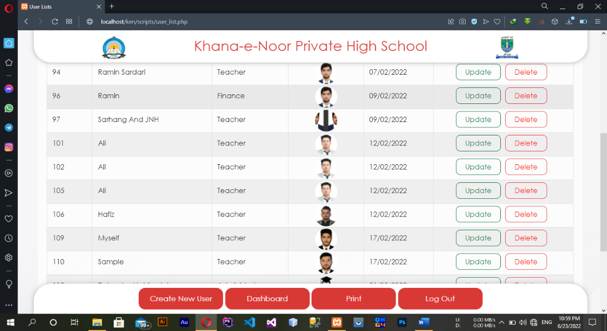Besides there is a trigger that after hiring a new teacher (saving new teacher information to the system) the system automatically creates its user account with the default username as teacher name and password as its phone number that is required to change after first login.

# Creating new account

As cleared previously, only admin users are able to create new users and the teacher account creates automatically. There is a certain page with some validations that lets an admin to add another employee to access the system.

A unique username, with verification of password greater than eight characters by double entry and loading user profile are validated data that the system accepts.

After the form directed to the user account or user’s information list. That all active accounts are shown with all data like create date but except password.

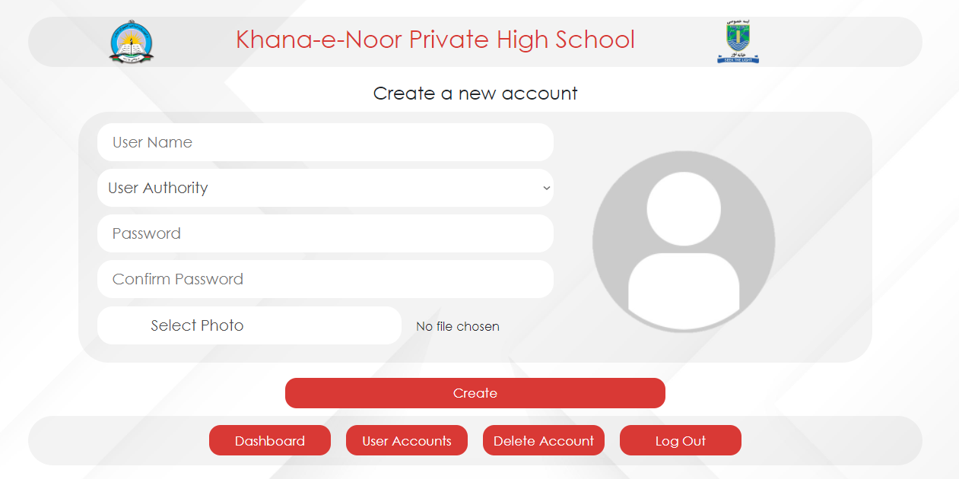

# Login page

The following figure is screenshot of the login page, user hover over the login box to enter their information for accessing the certain part of the system, the posters and the date time appear on the left after hovering the login box is dynamically changeable. There is a directory in the project’s folder named *Banners* contain 38 posters that the admin can change and renew it too.

The forget button on the bottom of the login box is used as a guidance for the users who forget their information which notified by the system to contact with an admin to reset the user’s information.

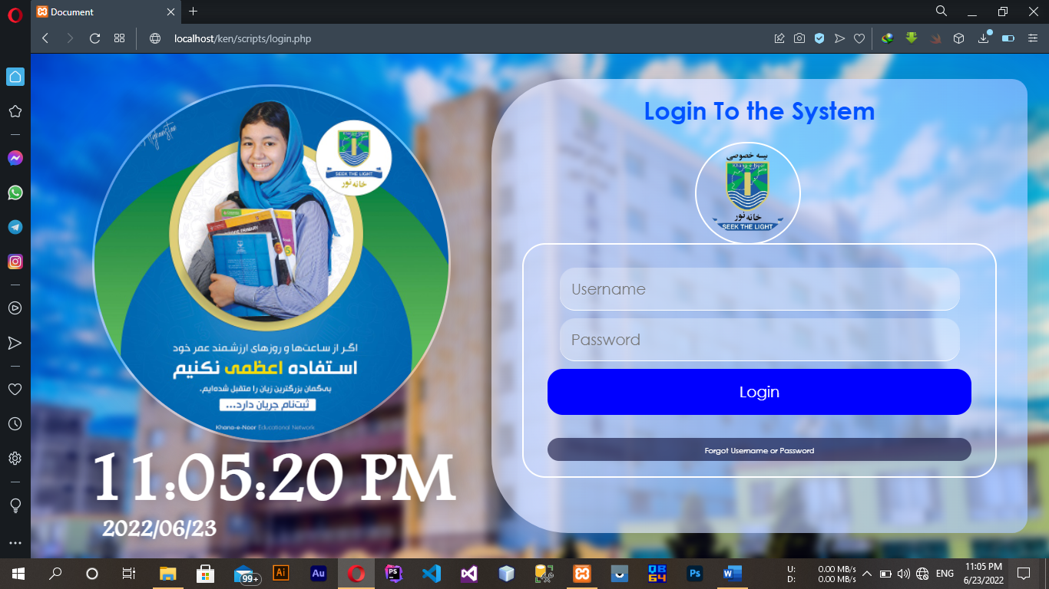

# Deleting and updating user accounts

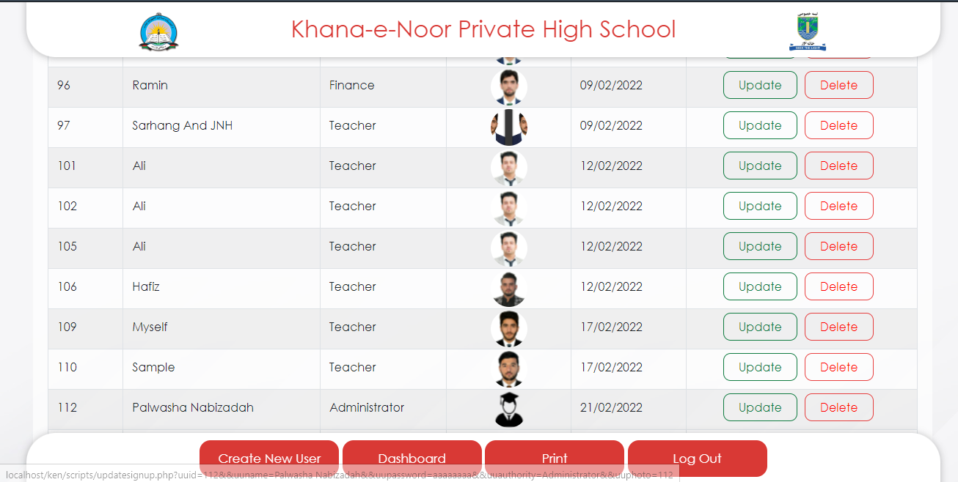In the page of user’s information next to the user’s name, authority, profile and create date, there are operations like *Delete* and *Update* but tons that the *Delete* button after confirmation delete the user and *Update* loads the record data to a page where the admin can edit or promote user’s authority to overwrite data as simple as possible.

# Chapter 4 | The dashboard

# 

*The administrator dashboard screen*

After user could signed in successfully, the first page he/she faces is the dashboard.

The dashboard or in other phrase the home page, contain an overview of overall about the trends and a glance on what’s going in in his specified section.

Chart and graphs are different based on the user type and the presentation of data, totally on this system as it looks necessarily every type of chart that could present numerical data better is used like pie chart, line chart, bar chart and column chart.

Assumption that a user like Bookshop officer sign in in the system there will be graph and chart all about the stock and sold book on its dashboard but if a finance sign in in the system there will be graph and charts of expenditure, payments and other important will be shown.

This helps the user to be aware of important content example the latest message, its username and authority, the graph and chart of data based on the user type or user section and more data that user needs to know every time.

The dashboard is a default page of all types of user where users from every other page can simple be redirected to this page by clicking on the dashboard button that is already adjusted on all other pages of the system.

Users can sign himself/herself out only on the dashboard button, as its designed the next page after signing is dashboard, the only page that can get to signing in is also the dashboard page.

On the left side there is a bit bigger button of navigation where the user accesses their allocated data tables or forms.

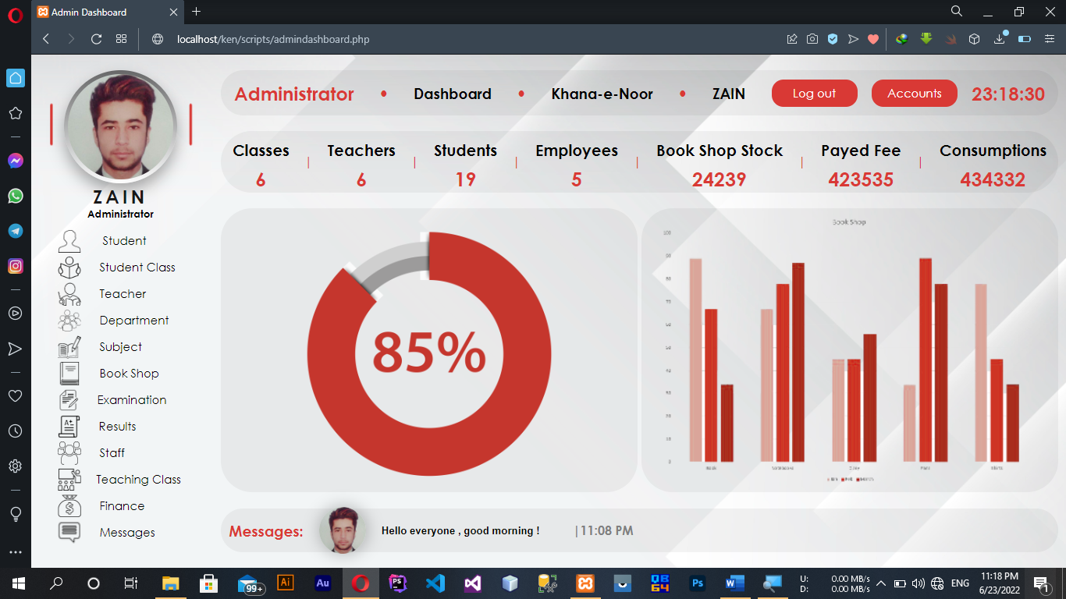User access this navigaion by hovering on the left side button, all the data that this user based on his/her user type can access like entering data, viewing data, deleting data or analysing the any group of data.

The finance users only have access on finincial sections like student payments, teachers salary, expenditures, orders and more…

The teacher users also have its specified accessibility to see students socre, edit it or delete it as this actions record for future inspection in the case of confidintualilty and security of data.

As the name of the user requires on every system the administrator users can access on the whole system, every single part of system is allowed to be accessed by administrator users sensitive or none sinsitive data, from messages to adding or inspecting users activity on the system.

# Accessing the system

All the pages and data on the system are embedded with special permission based on the type of the user like (Administrator, Head master, Finance….).

After a user login, only the related information will be available to deal with, add, edit, delete and manage the system’s data.

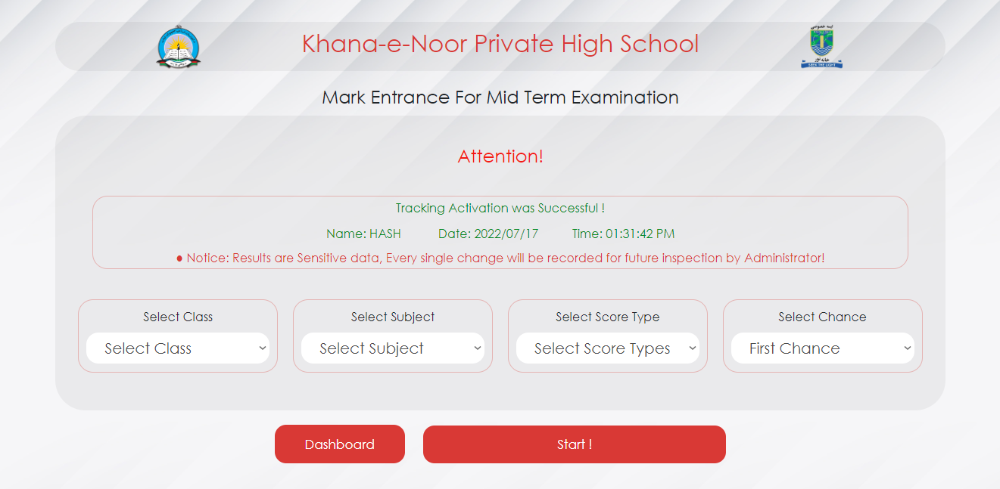

on sensitive information when any user add or remove any single bit of data will be recorded for future observation example editing student score, adding or updating sensitive information in this case there will be an attention mark shown at the top of the page that your activity is under inspection take care about dealing information.

# Login out

On the login the system out, there are some functions that and dispose all the existence cashes and sessions.

The main sessions that store data about the user like password for next easy login, user type, login time and username are important for users but it must be disposed after the user leave the system.

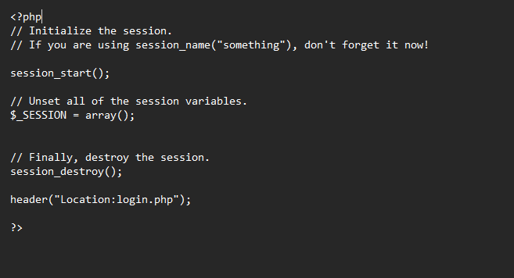When the user click on the sigh out button the current form direct the user to a virtual page that contain all the function and necessary code segments to remove all footprint of the user.

*When the session disposes*

# The messaging channel

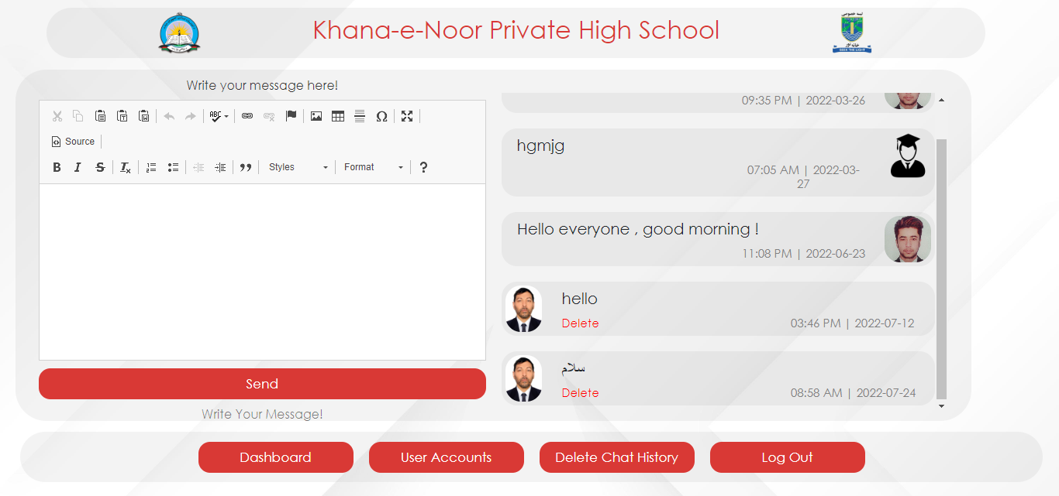

The success of every deal is when there is teamwork and every teamwork success is along with a deep coordination, this coordination is always keep up by an electronic messaging channel.

Herewith all the users inside the system no matter about that authority can see and send message broudcastly in the system where the other users can see the latest message on the below dashboard area specialized for the recent message.

As other public messaging channels the sender send its profile with the exact date and time to their audience, to know and attract quickly.

The sender can get decision to remove message anytime the sender of the message is the only owner, when the user be deleted all its message in the group will be remain as deleted user and nothing splashes.

The history also can be removed by only an admin user whereas the more joint users in the system with all authority this looks better to only the admin could delete the whole chat history.



*The latest message shown on the below dashboard.*